Application form for the course entitled ‘Development and Planning in African Cities’

This course is organised by Njala University and University College London and will run from June 11th until June 16th (Monday – Saturday), 2018.

Name
Gender
Date of birth
Would you consider yourself belonging to? | (1) academic researchers  (2) NGO practitioners,  (3) government agencies and service utilities,  (4) community leaders and residents of informal settlements  (5) university student/recent graduate
What organisation(s), group(s), communities do you represent, if applicable (or university programme you are attending)
What is your educational background?
Please explain why you are interested in taking this course.

_________________________________________________________________________________

_________________________________________________________________________________

_________________________________________________________________________________
How do you plan to use what you learn in this training in your future activities?
_________________________________________________________________________________

_________________________________________________________________________________

_________________________________________________________________________________

_________________________________________________________________________________

If you are employed, have you discussed with your organisation/employer about the course? Y / N
Do you have their permission to attend for the entire duration of the course? Y / N
Please state the name and position of the person who authorised you to attend the course:

__________________________________________________________________________

If accepted, I confirm that I will be able to attend all the sessions. Certificates will be given to those attending the full training programme (6 days).

Signature:
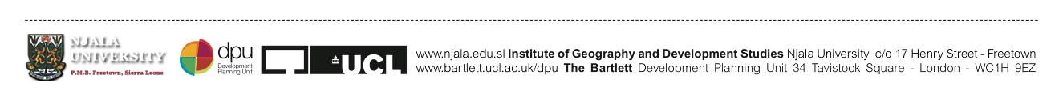
Forms to be returned in person to Ibrahim Kamara at the SLURC office: 63 Brook Street, Freetown, Monday-Friday 08:00-17:00 or sent to slurcapplication@gmail.com no later than May 25th, 2018. For more information please call +232 22 220 986

